***Group Tasks***

1. **Joe attached a helium filled balloon by a string to his seat. After driving for a while at a constant speed, he braked the car. Question: Relative to the seat, did the balloon move forward backwards, or not at all?**
2. **List 10 different possible uses of a coat hanger.(2 min.)**
3. **Race against the clock to sort two decks of cards randomly mixed together. (from Ace to King-without talking)**
4. **Scavenger Hunt**
5. **Get the hula hoop all the way around the circle without anyone letting go of their neighbors’ hands.(time-limit)**
6. **Untie all of the knots without anyone letting go of the rope or without moving the hand that is placed on the rope (participants may use only their free hand to untie knots).**
7. **In this activity, the team has to instruct their “artist” to draw an item. They have to describe their chosen item without revealing what it is and they are not able to see what the “artist” is drawing.**
8. **Recreate the wine glass without the fly in it. To complete the challenge, they are only allowed to move just two sticks. The remaining sticks and the fly must not move.**

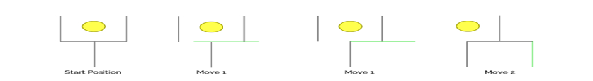

1. **Race against the clock to retrieve and move as many tennis balls from one bucket to another, without using hands or arms.**
2. **Race against the clock to touch all the numbers on the ‘calculator’ from 1 to 20 in sequence.**
3. **Complete a puzzle as quickly as possible.**
4. **Put together a story from a set of sequential images. Each person is given an image but is not permitted to show it to anyone else. Together, the team has to figure out the correct sequence.**
5. **A farmer is trying to cross a river. He is taking with him a rabbit, carrots and a fox, and he has a small raft. He can only bring 1 item a time across the river because his raft can only fit the rabbit, the carrots or the fox. How does he cross the river**
6. **You will see pairs of words, and your goal is to find a third word that is connected or associated with both of these two words.**

**-For example, the first pair is PIANO and LOCK. The answer is KEY. The word key is connected with both the word piano and the word lock: there are KEYS on a piano and you use a KEY to lock doors. Key is what is called a homograph: a word that has more than one meaning but is always spelled the same.**

**LOCK — PIANO**

**SHIP — CARD**

**TREE — CAR**

**SCHOOL — EYE**

**PILLOW — COURT**

**RIVER — MONEY**

**BED — PAPER**

**ARMY — WATER**

**TENNIS — NOISE**

**EGYPTIAN — MOTHER**

**SMOKER — PLUMBER**

1. **Of the 100 people at a recent party, 90 spoke Spanish, 80 spoke Italian, and 75 spoke Mandarin. At least how many spoke all three languages?**
2. **25- Is the inner shape a real circle?**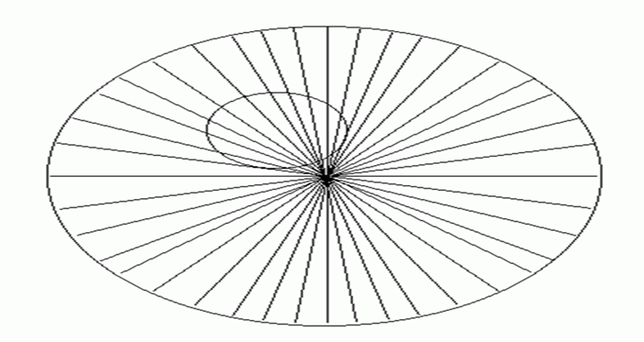
3. **Mention a traditional dish for each of the following countries:**
4. **Lebanon**
5. **Syria**
6. **Palestine**
7. **Italy**
8. **England**
9. **The “Golan Heights’ other name is “Shouting Valley”, why?**
10. **What is the story of the 2 stars in the Syrian flag?**
11. **The creators of Tom and Jerry are:**
12. **Mexican**
13. **Lebanese**
14. **Palestinian**
15. **Chinese**
16. **As for 2016, what is the largest refugee population in the world?**
17. **Place everyone in a circle around a long piece of rope that is tied at its ends to form a circle. Have everyone grasp the rope with both hands and hold the string waist high. Without letting go and blindfolded, the team will have to form shapes with the string; a square, a triangle, a figure eight**

***Individual Tasks***

1. **List 10 different possible uses of a book. (2 min.)**
2. **Use 6 Popsicle sticks to make 4 equilateral triangles.**
3. **Use marshmallow and pretzels to build at least a two-story structure that holds a beach ball.**
4. **Race against the clock to sort two decks of cards randomly mixed together.**
5. **Scavenger Hunt**
6. **Untie all of the knots without letting go of the rope or without moving the hand that is placed on the rope (participant may use only his/her free hand to untie knots).**
7. **Race against the clock to retrieve and move as many tennis balls from one bucket to another, without using hands or arms.**
8. **Complete a puzzle as quickly as possible.**
9. **Put together a story from a set of sequential images.**
10. **The team has become stranded on three separate islands. Each island needs to have food, water and a radio for the team to survive until rescue. The islands are too far apart to jump between. The team must devise a plan in order to get all required survival items to all Islands using limited equipment.**
11. **In which direction is the bus pictured below traveling?**

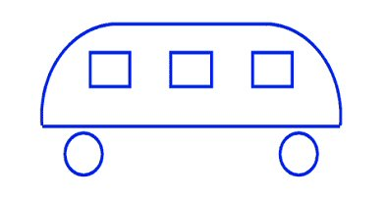

1. **A blind beggar had a brother who died. What relation was  
   the blind beggar to the brother who died?  
   “Brother” is not the answer.**
2. **What is the name of:**
3. **The Syrian traditional dance**
4. **The Palestinian traditional dance**
5. **The Lebanese traditional dance**
6. **Do 20 pushups**
7. **Why is Beirut compared to the Phoenix?**
8. **Which is the first Arab country that had a constitution?**
9. **Flip over the glass to get the ping pong ball inside( 7 out of 10 times)**
10. **What goes up and never comes down?**
11. **Stack 28 plastic cups in a pyramid shape, and unstack them all back in 60 seconds or less.**
12. **Using only your facial muscles, each player must move a cookie from the top of their head, down their face, and into their mouth without dropping the cookie.**
13. **While holding a craft stick in your mouth, player must stack 6 dice on top of each other on the end and hold for 3 seconds.**
14. **Using a long piece of spaghetti in your mouth, stack 6 penne pasta in a row in 60 seconds or less.**
15. **Using toilet paper and a member of your group, create a mummy in 2 min.**
16. **Throw the beach ball to the basket (at the end of the room) 7 out of 10.**